|  |  |  |
| --- | --- | --- |
| PDR | February 10  2016 | |
| Making Facility Management more intelligent and efficient. | | Preliminary Design Review |

|  |  |  |  |
| --- | --- | --- | --- |
| **Revision record** | | | |
| Version | Date | Authors | Comment |
| 1.0 | 04.05.16 | Arshad Shakil,  Badis Madani,  [Håkon Hedlund](https://www.facebook.com/hakon.hedlund)**,**  Zhili Shao |  |

Contents

1. System Requirements Analysis 3

2. Function Analysis 4

3. Function Block Diagram 5

4. IEF0 Diagram 7

5. Human-machine interfaces 7

6. Parameter Scope 9

7. Modes description 9

8. ANNEX 10

8.1 Function Analysis Block Diagram 10

# System Requirements Analysis

Based on the stakeholders' requirements, existing solutions for HVAC control, SFM team identified system requirements for the HVAC control system, Table 1.1 green part lists the requirements of a smart HVAC control system may have, the first column shows the corresponding stakeholder requirements they satisfy. COTS column shows the modules will be used to implement system requirements. The classification has three level: “Must to have” means the functions can be found in normally used thermostat, which is the existing HVAC control panel we want to change. “Nice to have” means the functions that are preferred to add to existing HVAC control panel according to SFM team’s survey to users. “Desirable” means functions also are preferred, but SFM team don’t have enough time and capability to implement. The HVAC control panel will be improved with “desirable” function when the SFM team get enough resource.

|  |  |  |  |
| --- | --- | --- | --- |
| **Stakeholder Requirement** | **System Requirement** | **COTS** | **Classification** |
| Monitor and adjust temperature | Collect temperature data for display and computation | Temperature Sensor | Must to have |
| Monitor humidity | Collect humidity data for display and computation | Humidity Sensor | Must to have |
| Monitor and adjust CO2-level | Collect CO2-level data for display and computation | CO2 Sensor | Must to have |
| Ease of use, Accessibility | Provide UI to interact with user | Touchscreen | Must to have |
| Ease of use | UI reaction logic, Communication with sensors, Data calculation, HVAC control signal output. | Microcontroller | Must to have |
| Adjust indoor environment, Compatibility with existing HVAC system, Ease of deployment | Connect to HVAC controller | 4-Channel Relay Module | Must to have |
| Adjust humidity | Increase air humidity | Humidifier | Nice to have |
| Ease of use | Change the configuration of indoor temperature according to time. | Microcontroller | Nice to have |
| Energy saving, Ease of use | Automatically switch to economy mode | Motion Sensor | Nice to have |
| Ease of use | Collect weather information from internet | WIFI module, weather forecast website | Desirable |
| Accessibility, Ease of use | To tell information and setting about HVAC system using voice for blind people or people in dark room. | WIFI module, Voice interaction server | Desirable |
| Cost of implementation | Give user access to get information and setting HVAC system by website. | WIFI module, Website | Desirable |
| Ease of use | Give user access to get information and setting HVAC system by mobile phone. | WIFI module, Apps | Desirable |

Table 1.1 System Requirement Analysis

# Function Analysis

Figure 2.1 shows overview of the Function Analysis Block Diagram, more detail can be found form ANNEX 7.1. First level shows the system requirements. Left three with red boundary are the system requirements “Nice to have”, and they are designed as the new functions will make the thermostat smarter. The right part illustrates function analysis of existing thermostat, they are very commonly used in our daily lift for home and office buildings.



Figure 2.1 Functions Analysis Block Diagram

# Function Block Diagram

Figure 3.1 show the function block diagram of HVAC control panel, and it mainly focus on the new requirements that will make HVAC control smart for user to use. The three new function are the “Nice to have” functions mentioned in table 1.1.



Figure3.1 Function Block Diagram

# IEF0 Diagram



Figure 4.1 IEF0 Diagram

# Human-machine interfaces

SFM team designed the human-machine interfaces for the HVAC control system. Figure 4.1 shows the default page which are mostly used by users. Firstly, user can easily get access to time, weekday, date from the left part of screen, touch their position to change their value. In the middle area of the screen, it provides the information of temperature, humidity and CO2-level. Through the buttons “+” and “-”, users can easily set the values of temperature and humidity they want, the CO2 threshold stands for when indoor CO2 reach to this level, Fan start to work to decrease CO2 level. When users push the button, the parameters will increase or decrease one unite every time. If user hold the buttons for a period of time, the values can increase or decrease quickly. Motion sensor waiting time can be increased or decreased half one-hour every time. When the room is not occupied for this period of time, the HVAC system will switch to economy mode automatically. For the Fan control, users can turn on it or set to Auto. When the cooler or heater start to work, the fan will turn on. Also it will start to work when the CO2-level higher than set threshold. There are three modes for the HVAC control, cool mode will active the air conditioner to work, its boundary will become green when it is active, heat mode will active the heater to work. On SCH mode, thermostat will operate according to schedule. Pushing “OFF” button, HVAC system will stop to work, but the time and indoor environment area still shows the real-time parameters. Users can also configure the parameters, then the setting will be available when the HVAC system starts to work. Pushing “SET SCHEDULE” will enter the user interface for schedule setting, Figure 4.2 shows the user interface of “SET SCHEDULE”.

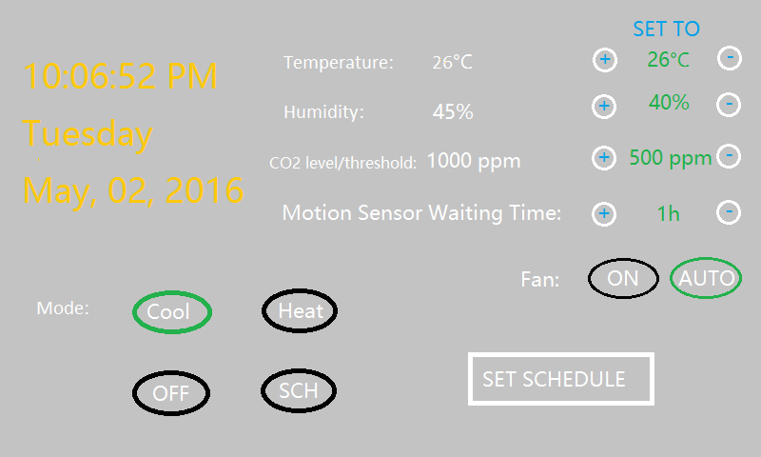

Figure 5.1 Default Page

Users can set the temperature schedule for one week. For certain day, users can choose one time through the black stick, and a dialog block will appear like the green-boundary block. Users can set the temperature they want at this time point, choosing “Save” button to save or “Delete” button to delete setting. Here only temperature will be set, because it’s the most sensitive parameter which people concerns about. For humidity and CO2-level, it will be stable once users set them to a proper value.

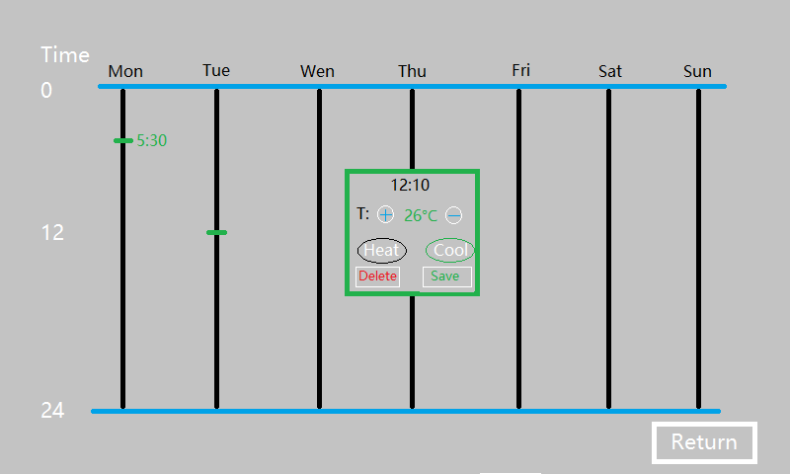

Figure 5.2 SET SCHEDULE

# Parameter Scope

Power Supply: 24V 15W (from HVAC controller)

Temperature Regulation Range: 10℃ to 30℃ (change 1℃ every time)

Relative Humidity Regulation Range: 25% to 60% (change 1% every time)

CO2-level Regulation Range: 500ppm to 2000ppm (change 50ppm every time)

Motion Sensor Waiting Time: 0.5h to 5h (change 0.5h every time)

# Modes description

The different modes work as follows:

Cool mode:  
  
When using the cool mode, the system will only use the air conditioner. This air conditioner will only trigger if the temperature in the room can actually be lowered. If the temperature in the room keeps increasing due to outside temperature, the air conditioner will keep working to lower it. But if the user sets the temperature to higher than current temperature in the room, the air conditioner will not work if cool mode is set. This mode requires the user to take into consideration how the room is going to be regulated according to the current temperature.

Heat mode:  
  
When using the heat mode, the system will only use the heater of the HVAC system. The heater triggers if the temperature in the room is lower than the set temperature. If the temperature keeps getting lower in the room, the heater will kick in and work to increase the temperature. Just like the cool mode, the heat mode will not work if the current temperature is higher than the current temperature in the room. If the user wants to cool the room, they need to pick the cool mode.

Off mode:  
  
This mode turns off the regulation of the room all together. It does not regulate temperature, humidity, CO2 level. This is meant for situations where the system is not needed to be operational.

# ANNEX

## Function Analysis Block Diagram

